Worcester Royal Infirmary Nurses League
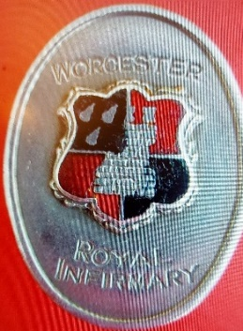
Dear member, we look forward to seeing you at the 2026 reunion.
Worcester Royal Infirmary Nurses League annual reunion and AGM:
Saturday May 16th, 2026
Worcestershire County Cricket Ground
New Road Worcester. WR2 4QQ
Theme: Celebrating 75yrs of WRI Nurses league.
The day will commence at 11:00 and close at 16:30. Refreshments on arrival.

Funds from the raffle will go to charity, confirmed on the day. (Cash only please as we do not have a card reader).
Bookmarks depicting the Jenny Lind, stained glass window will be available to purchase for £2

A hot lunch is provided and a licensed bar available.

Find us on Facebook - Worcestershire Nurses League

---------------------------------------------------------------------------------------------------------------
Please complete and return this slip no later than April 20th, 2026, for planning purposes.
Return to: Julie Poultney: 22 The Parklands Droitwich WR9 7DG. 01905 779985. julie_poultney@hotmail.co.uk
Full Name
Postal Address
Post code
Telephone number
Email address
Please Tick as appropriate: |  | Yes | No
I will be attending the reunion
Cost of day including lunch £25.00
Dietary requirements/Allergies |  |  |  | Details | vegetarian
Donations for the nurses League |  |  |  | Amount
Cheques payable to: Worcester Royal Infirmary Nurses League
Or pay by bank transfer: Sort Code:30-99-90 Account number: 02044078
Important- please add a unique reference code. Your surname and postal code.

Please pay by BACS where possible. Send cheques with form to the address above.
Many Thanks

Your details will be held on a computer database purely for the notification of WRINL events. The information is not shared with any 3rd parties and stored in accordance with GDPR legislation.

